

09 – Dictionary

Department of Computer Science and Engineering

| Rajalakshmi Engineering College

PA. GE

Department of Computer Science and Engineering

| Rajalakshmi Engineering College

PA. GE
Ex. No. : 9.1 Date: 29.05.2024

Register No.: 231401020 Name: BHUVANESWARI S

Uncommon words

A sentence is a string of single-space separated words where each word consists only of lowercase letters.A word is uncommon if it appears exactly once in one of the sentences, and does not appear in the other sentence.

Given two sentences s1 and s2, return a list of all the uncommon words. You may return the answer in any order.

Example 1:

Input: s1 = "this apple is sweet", s2 = "this apple is sour"

Output: ["sweet","sour"]

Example 2:

Input: s1 = "apple apple", s2 = "banana"

Output: ["banana"]

Constraints:

1 <= s1.length, s2.length <= 200

s1 and s2 consist of lowercase English letters and spaces.

s1 and s2 do not have leading or trailing spaces.

All the words in s1 and s2 are separated by a single space.

Note:

Use dictionary to solve the problem

For example:

Input | Result
this apple is sweet | sweet sour
this apple is sour

a=input().split()

Department of Computer Science and Engineering | Rajalakshmi Engineering College

PA.

GE

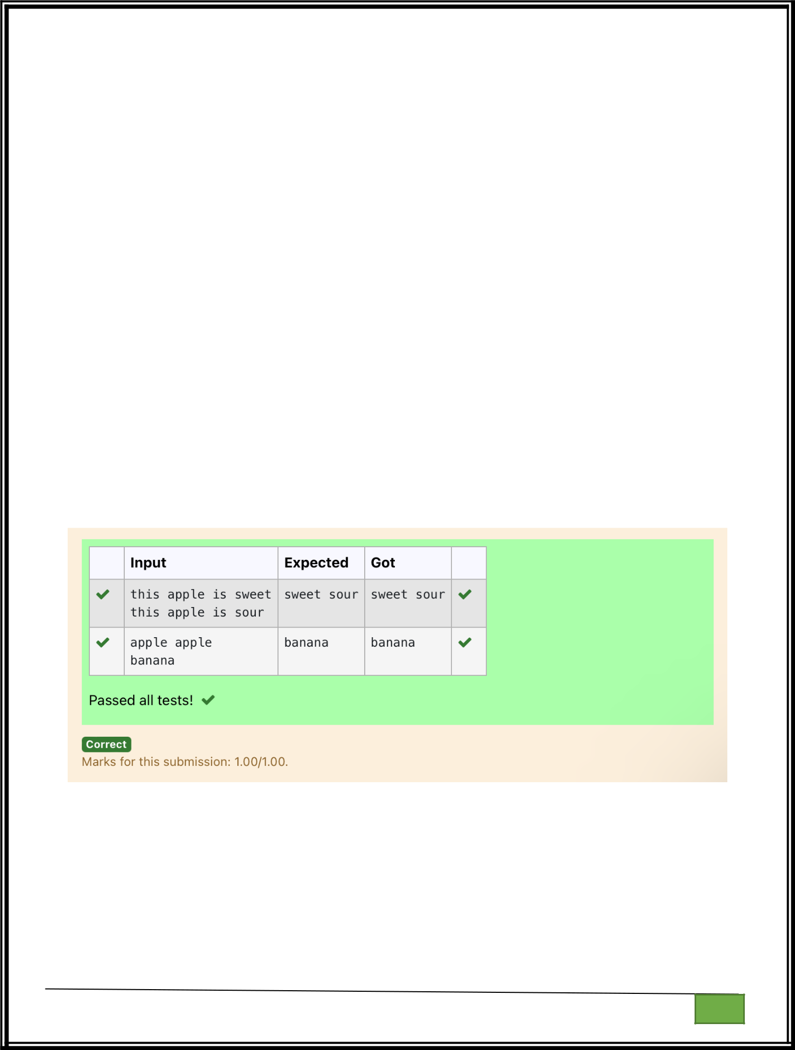
b=input().split()

c1,c2,l={},{},[]

for i in a:

c1[i]=c1.get(i,0)+1

for j in b:

c2[j]=c2.get(j,0)+1

for w,c in c1.items():

if(c==1 and w not in b):

l.append(w)

for w,c in c2.items():

if(c==1 and w not in a):

l.append(w)

print(*l)

Department of Computer Science and Engineering | Rajalakshmi Engineering College

PA.

GE

Department of Computer Science and Engineering

| Rajalakshmi Engineering College

PA. GE

Ex. No.

:

9.2

Date: 29.05.2024


Register No.: 231401020

Name :BHUVANESWARI S

Sort Dictionary by Values Summation

Give a dictionary with value lists, sort the keys by summation of values in value list.

Input : test_dict = {‘Gfg’ : [6, 7, 4], ‘best’ : [7, 6, 5]}

Output : {‘Gfg’: 17, ‘best’: 18}

Explanation : Sorted by sum, and replaced.

Input : test_dict = {‘Gfg’ : [8,8], ‘best’ : [5,5]}

Output : {‘best’: 10, ‘Gfg’: 16}

Explanation : Sorted by sum, and replaced.

Sample Input:

2

Gfg 6 7 4

Best 7 6 5

Sample Output

Gfg 17

Best 18

For example:

Input

Result

2 Gfg 17
Gfg 6 7 4 Best 18

Best 7 6 5

a=int(input())

d={}

for i in range(a):

Department of Computer Science and Engineering

| Rajalakshmi Engineering College

PA. GE

b=input()

b=b.partition(" ")

d[b[0]]=b[-1].split(" ")

n=list(d.values())

k=list(d.keys())

for i in range(len(n)):

s=0

for j in range(len(n[i])):

s+=int(n[i][j])

d.update({k[i]:s})

l=list(d.items())

if(l[0][1]<l[1][1]):

for k,v in d.items():

print(k,v)

else:

j=1

for k,v in d.items():

if(j==1):

k1,v1=k,v

j+=1

else:

print(k,v)

print(k1,v1)

Department of Computer Science and Engineering

| Rajalakshmi Engineering College

PA. GE

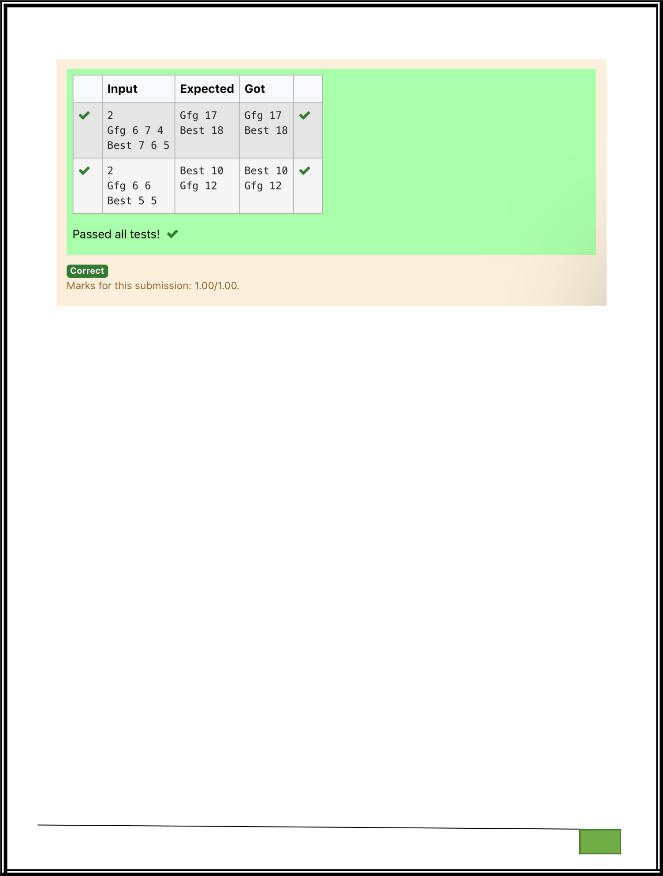

Department of Computer Science and Engineering

| Rajalakshmi Engineering College

PA. GE

Department of Computer Science and Engineering

| Rajalakshmi Engineering College

PA. GE
Ex. No. : 9.3 Date: 29.05.2024

Register No.: 231401020 Name: BHUVANESWARI S

Winner of Election

Given an array of names of candidates in an election. A candidate name in the array represents a vote cast to the candidate. Print the name of candidates received Max vote. If there is tie, print a lexicographically smaller name.

Examples:
Input : votes[] = {"john", "johnny", "jackie",

"johnny", "john", "jackie",
"jamie", "jamie", "john",

"johnny", "jamie", "johnny",
"john"};

Output : John
We have four Candidates with name as 'John', 'Johnny', 'jamie', 'jackie'. The candidates

John and Johny get maximum votes. Since John is alphabetically smaller, we print it.
Use dictionary to solve the above problem

Sample Input:
10
John

John
Johny

Jamie
Jamie

Johny
Jack

Johny
Johny

Jackie

Sample Output:
Johny

For example:

Inpu | Result
t | Result
10 | Johny

Department of Computer Science and Engineering | Rajalakshmi Engineering College

PA.

GE

  Inpu | Result
t | Result

John
John

Johny
Jamie

Jamie
Johny

Jack
Johny

Johny
Jackie

n = int(input())

votes = {}

for _ in range(n):

candidate = input()

votes[candidate] = votes.get(candidate, 0) + 1

max_votes = max(votes.values())

max_candidates = [candidate for candidate, count in votes.items() if count == max_votes]

print(min(max_candidates))

Department of Computer Science and Engineering | Rajalakshmi Engineering College

PA.

GE

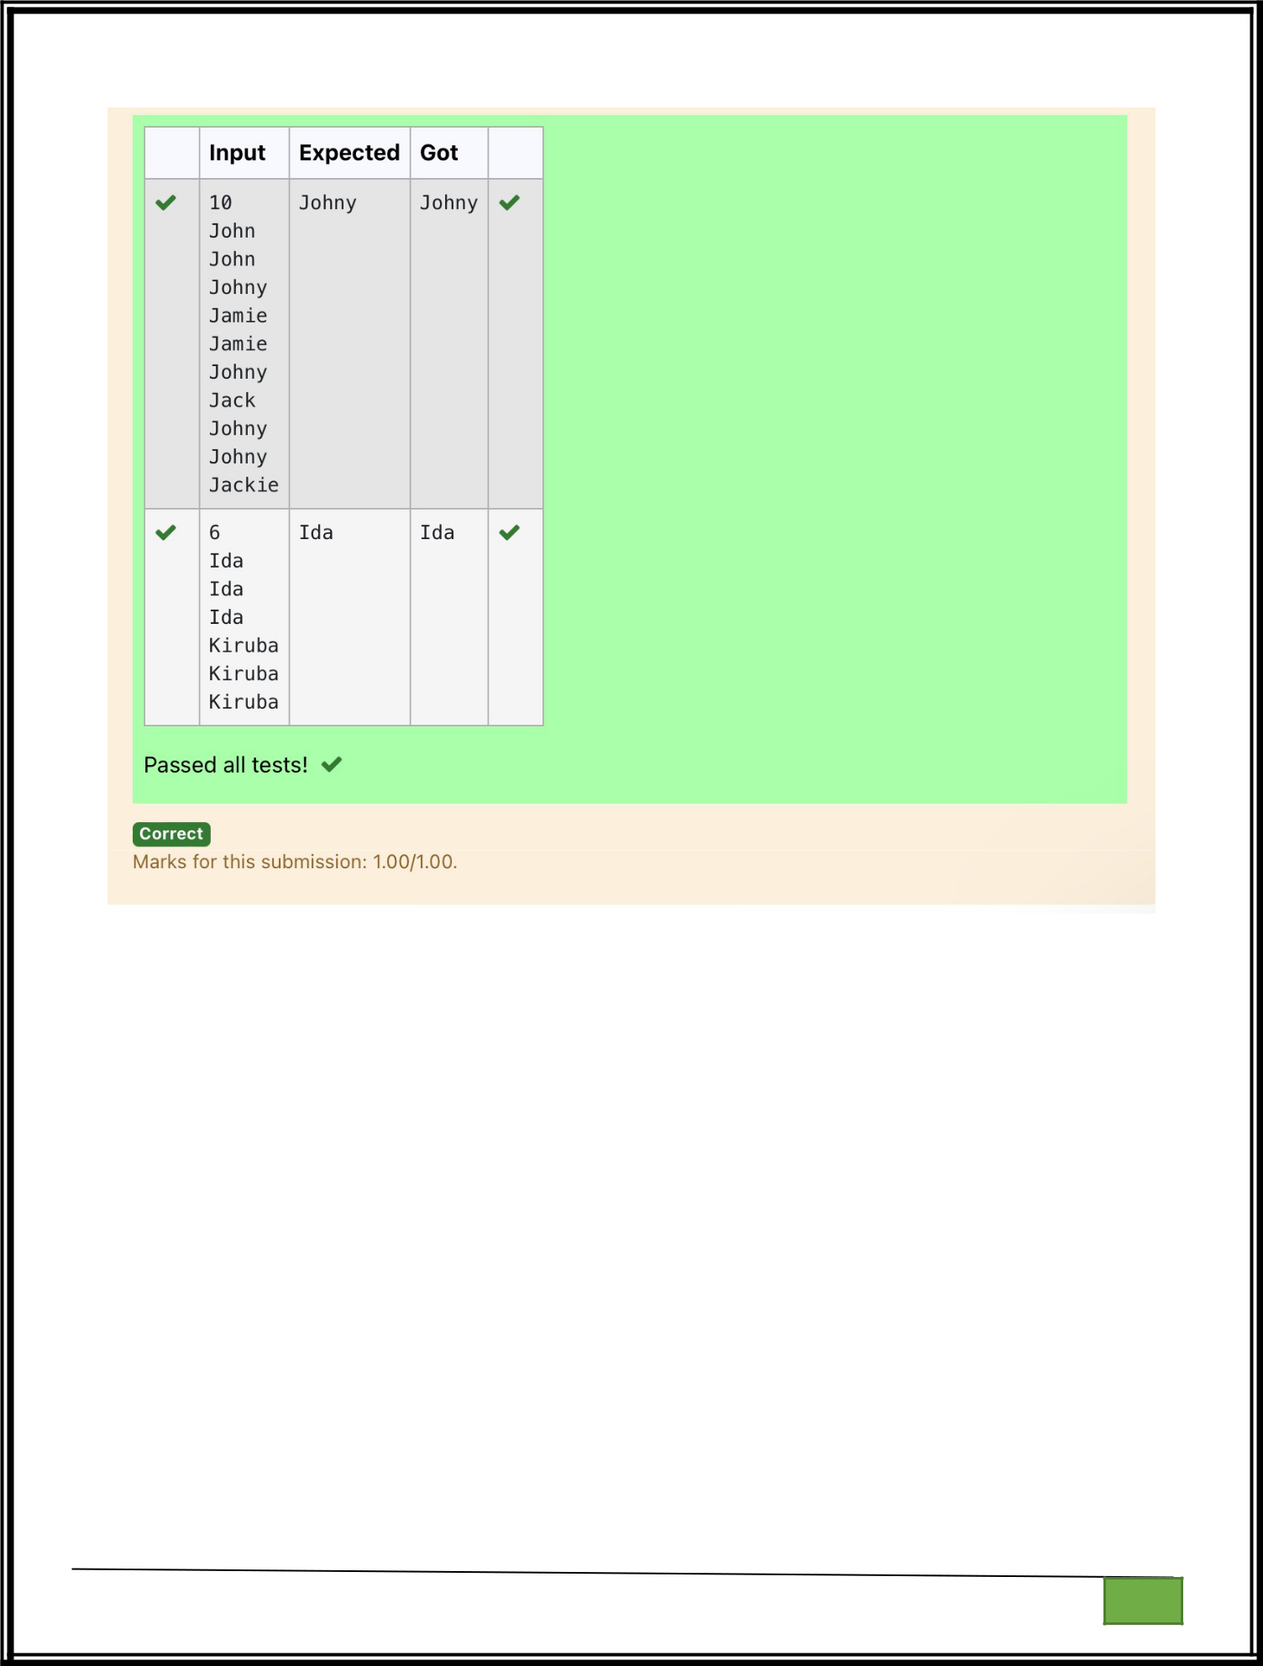

Department of Computer Science and Engineering

| Rajalakshmi Engineering College

PA. GE

Department of Computer Science and Engineering

| Rajalakshmi Engineering College

PA. GE
Ex. No. : 9.4 Date: 29.05.2024

Register No.: 231401020 Name: BHUVANESWARI S

Student Record

Create a student dictionary for n students with the student name as key and their test mark assignment mark and lab mark as values. Do the following computations and display the result.
1.Identify the student with the highest average score

2.Identify the student who as the highest Assignment marks
3.Identify the student with the Lowest lab marks

4.Identify the student with the lowest average score
Note:

If more than one student has the same score display all the student names

Sample input:

4

James 67 89 56

Lalith 89 45 45

Ram 89 89 89

Sita 70 70 70

Sample Output:

Ram

James Ram

Lalith

Lalith

n = int(input())
max_average = float('-inf')

min_average = float('inf')
max_assignment = float('-inf')

min_lab = float('inf')
max_average_students = []

max_assignment_students = []
min_lab_students = []

min_average_students = []

Department of Computer Science and Engineering | Rajalakshmi Engineering College

PA.

GE

for _ in range(n):
name, test, assignment, lab = input().split()

test = int(test)
assignment = int(assignment)

lab = int(lab)
average = (test + assignment + lab) / 3

if average > max_average:
max_average = average

max_average_students = [name]
elif average == max_average:

max_average_students.append(name)
if average < min_average:

min_average = average
min_average_students = [name]

elif average == min_average:
min_average_students.append(name)

if assignment > max_assignment:
max_assignment = assignment

max_assignment_students = [name]
elif assignment == max_assignment:

max_assignment_students.append(name)

if lab < min_lab:

min_lab = lab
min_lab_students = [name]

elif lab == min_lab:
min_lab _students.append(name)

print(*sorted(max_average_students))
print(*sorted(max_assignment_students))

print(*sorted(min_lab_students))
print(*sorted(min_average_students))

Department of Computer Science and Engineering | Rajalakshmi Engineering College

PA.

GE

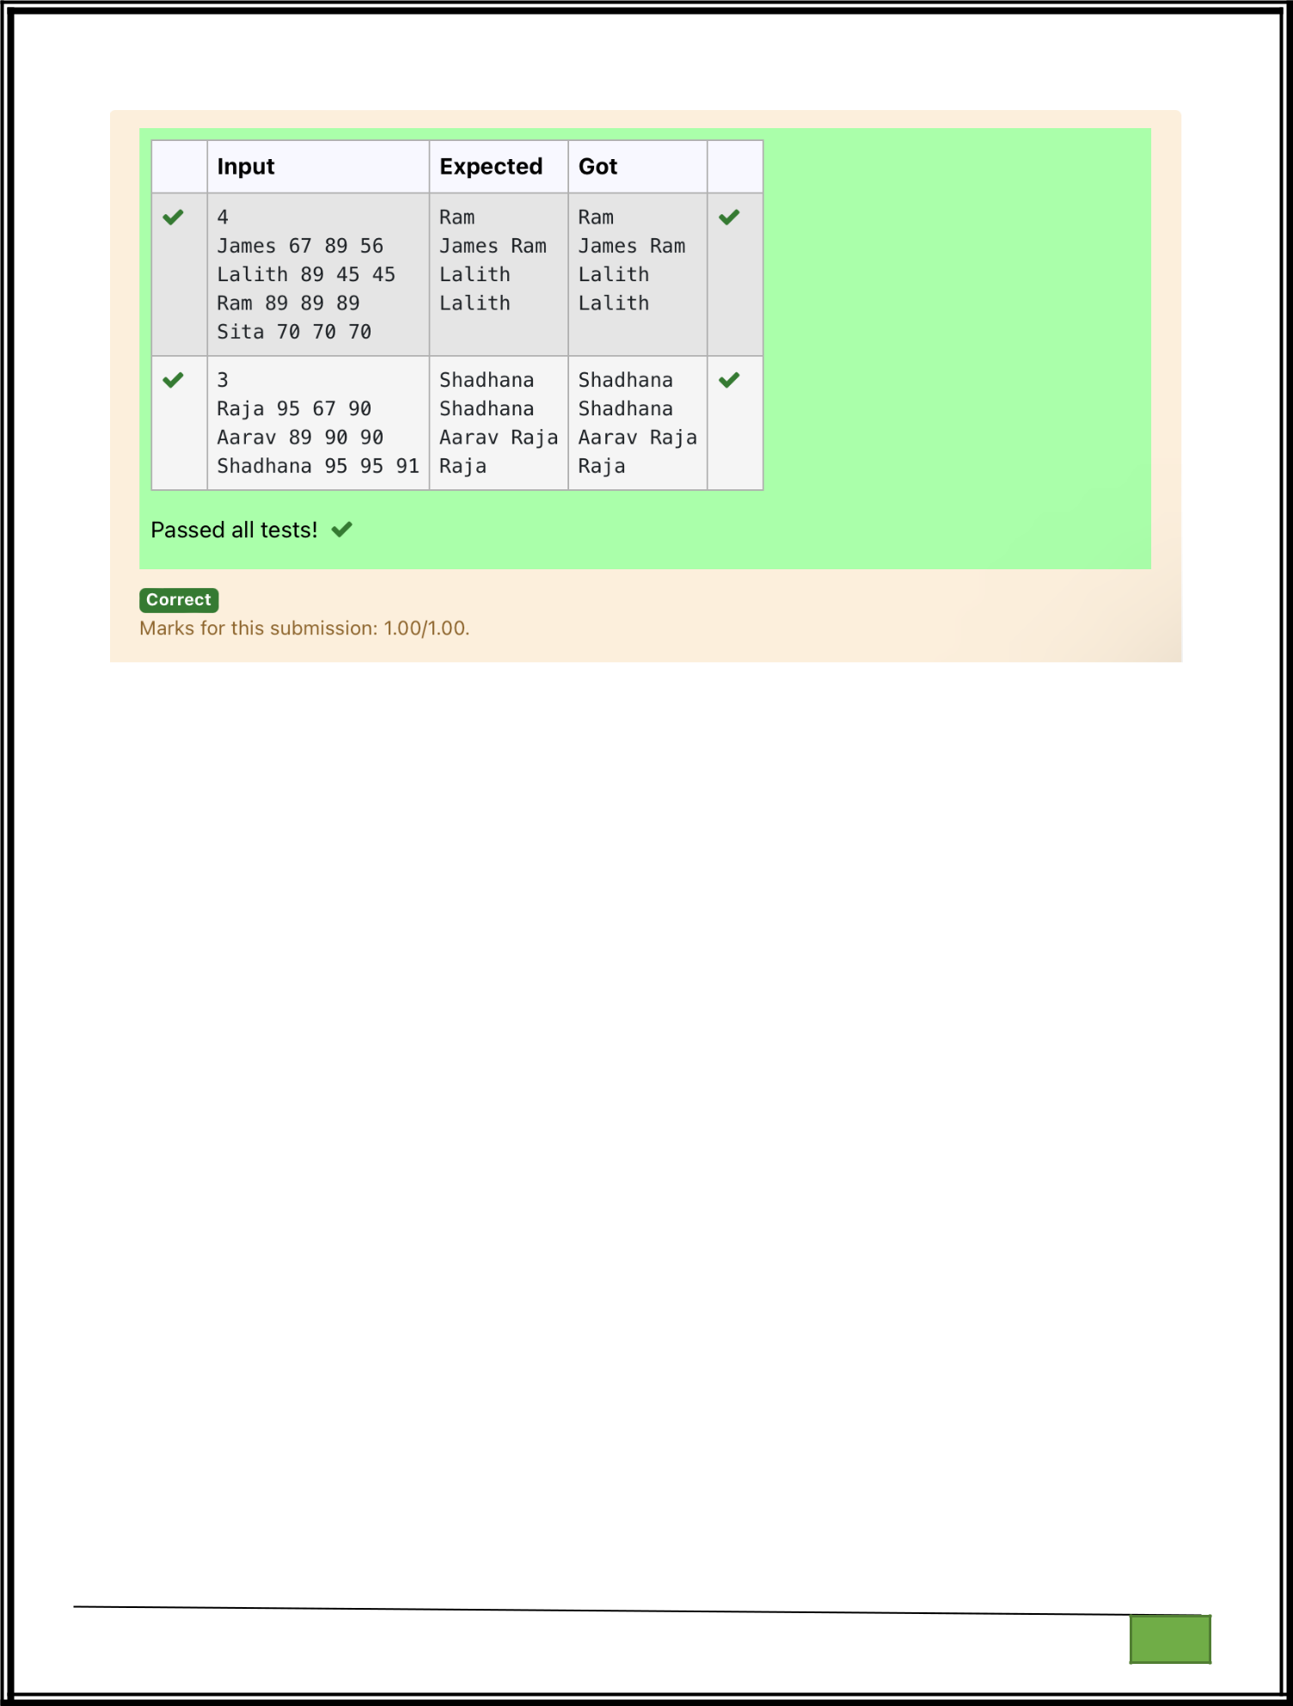

Department of Computer Science and Engineering

| Rajalakshmi Engineering College

PA. GE

Department of Computer Science and Engineering

| Rajalakshmi Engineering College

PA. GE
Ex. No. : 9.5 Date: 29.05.2024

Register No.: 231401020 Name: BHUVANESWARI S

Scramble Score

In the game of Scrabble™, each letter has points associated with it. The total score of a word is the sum of the scores of its letters. More common letters are worth fewer points while less common letters are worth more points.

Write a program that computes and displays the Scrabble™ score for a word. Create a dictionary that maps from letters to point values. Then use the dictionary to compute the score.

A Scrabble™ board includes some squares that multiply the value of a letter or the value of an entire word. We will ignore these squares in this exercise.

The points associated with each letter are shown below:

Points Letters

1 A, E, I, L, N, O, R, S, T and U

2 D and G

3 B, C, M and P

4 F, H, V, W and Y

5 K

8 J and X

10 Q and Z

Sample Input

REC

Sample Output

REC is worth 5 points.

letter_scores = {

'A': 1, 'E': 1, 'I': 1, 'L': 1, 'N': 1, 'O': 1, 'R': 1, 'S': 1, 'T': 1, 'U': 1,
'D': 2, 'G': 2,

'B': 3, 'C': 3, 'M': 3, 'P': 3,
'F': 4, 'H': 4, 'V': 4, 'W': 4, 'Y': 4,

Department of Computer Science and Engineering | Rajalakshmi Engineering College

PA.

GE

}
'K': 5,
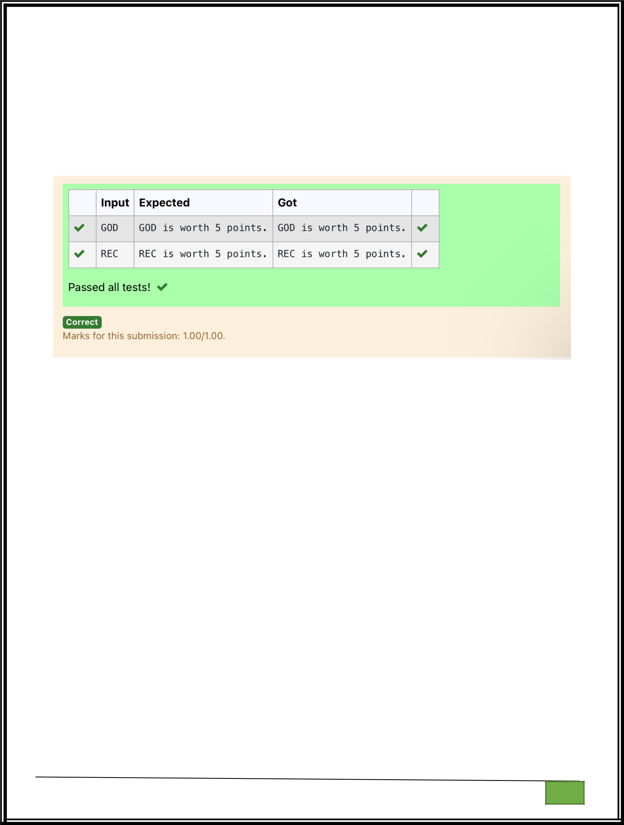
'J': 8, 'X': 8,

'Q': 10, 'Z': 10

word = input().upper()
score = sum(letter_scores.get(letter, 0) for letter in word)

print(word,"is worth",score,"points.")

Department of Computer Science and Engineering | Rajalakshmi Engineering College

PA.

GE

